App & Web servers Daily Task

- Install nginx and run nginx on port number 81.
- Deploy a sample index.html file on nginx

- Create an one EC2 instance in AWS with existing key pair.
- After that make sure in EC2 security groups make sure to edit the inbound rules selecting as All traffic and save rules.
- Now open the already downloaded key pair in Downloads folder & right click and open the GIT bash.
- For SSH connection the command to run is
ssh -i linux_testing.pem ec2-user@3.91.236.52
- After successful connection now switch to root user, sudo su –
- Next run, yum install nginx -y
- After successful download run, systemctl start nginx.
- Then check status, systemctl status nginx.
- Once the status is shown loaded & active we can check the default assigned port by using ps -ef | grep nginx or netstat-na | grep 80 or lsof -I tcp:80.
- We can check the static page in browser with ip address:port no.
http://3.91.236.52:80
- Default deployment location: /usr/share/nginx/html
- To change the port number to 81 we need to go to the conf file present in /etc/nginx/nginx.conf
- By taking the backup of the nginx.conf file we need to make changes to the conf file as port 82 by using the vi editor.
- Now restart the service with systemctl restart nginx
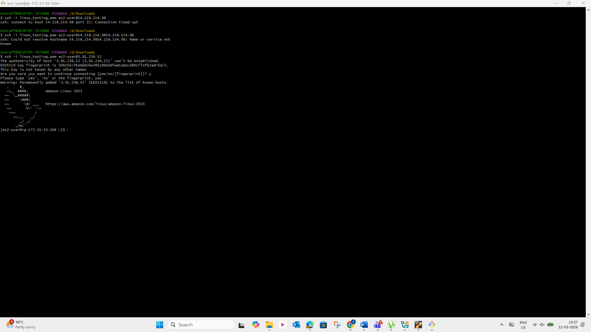

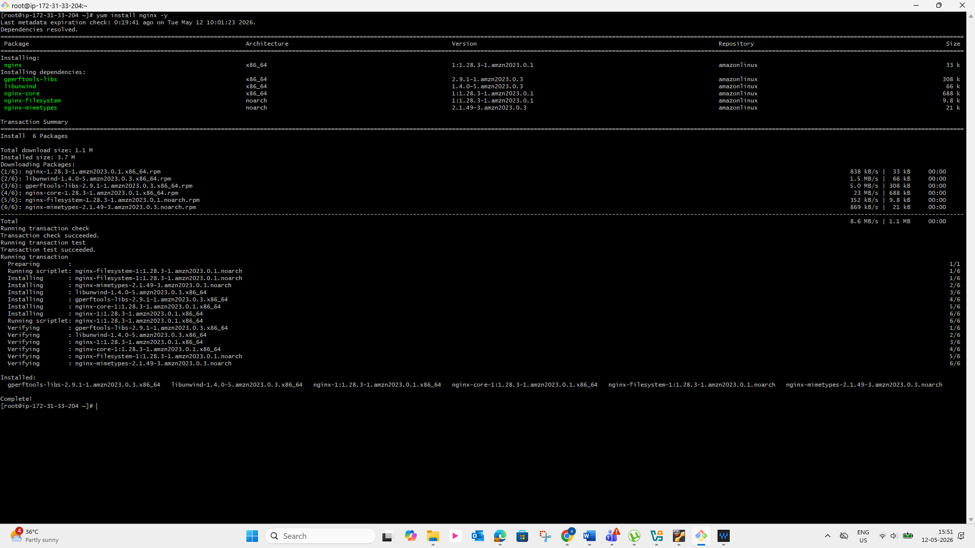

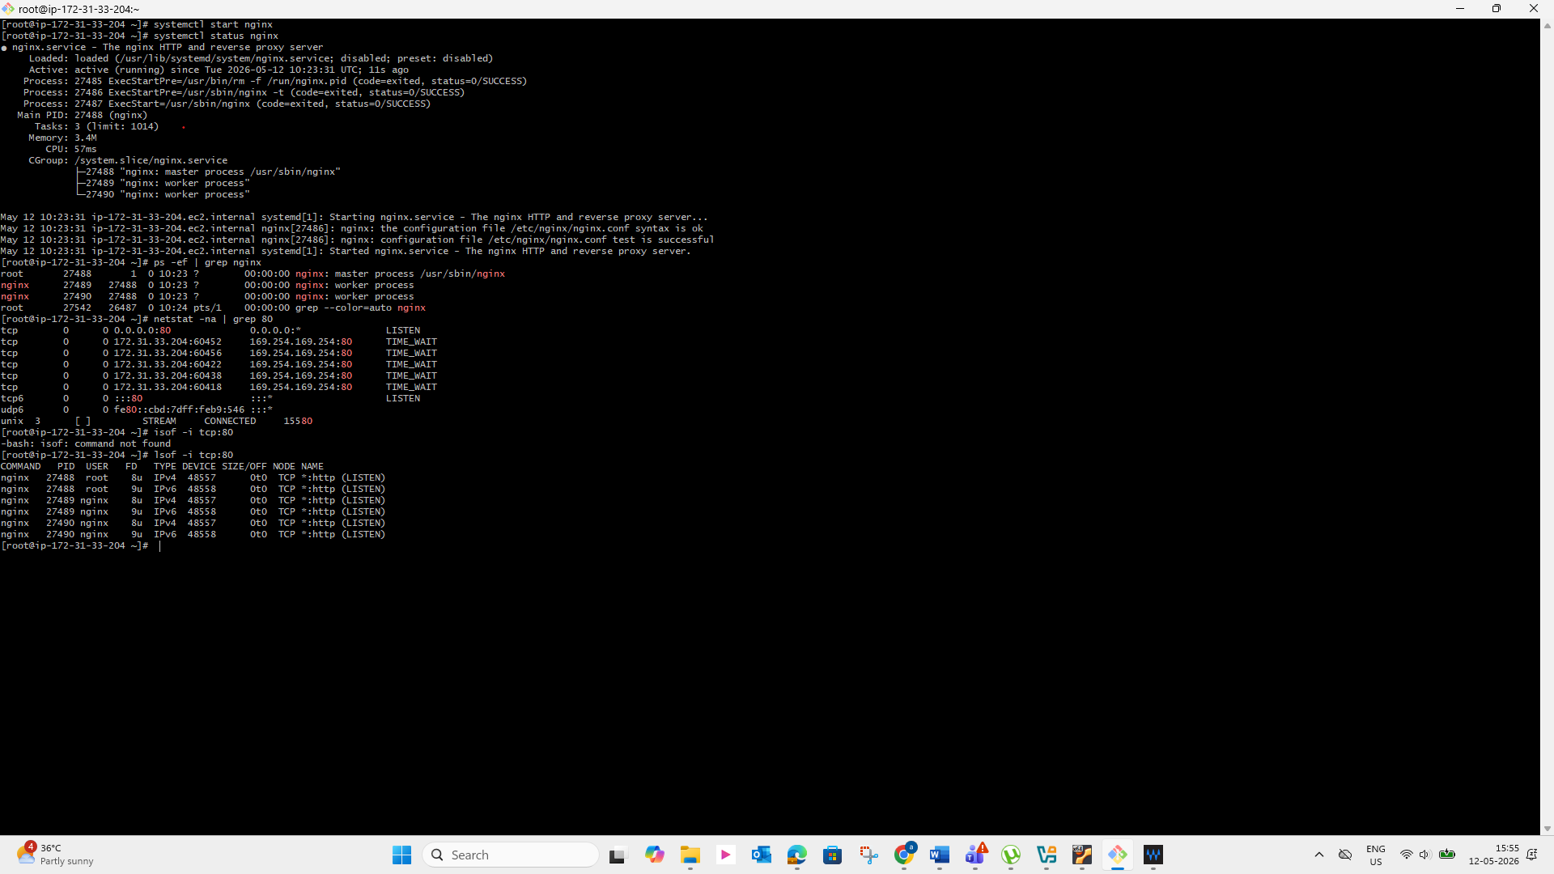

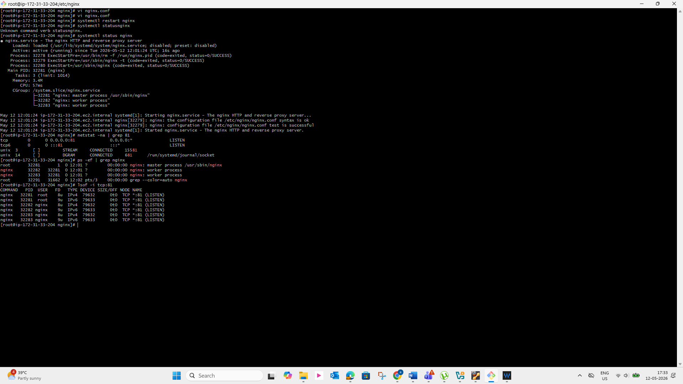
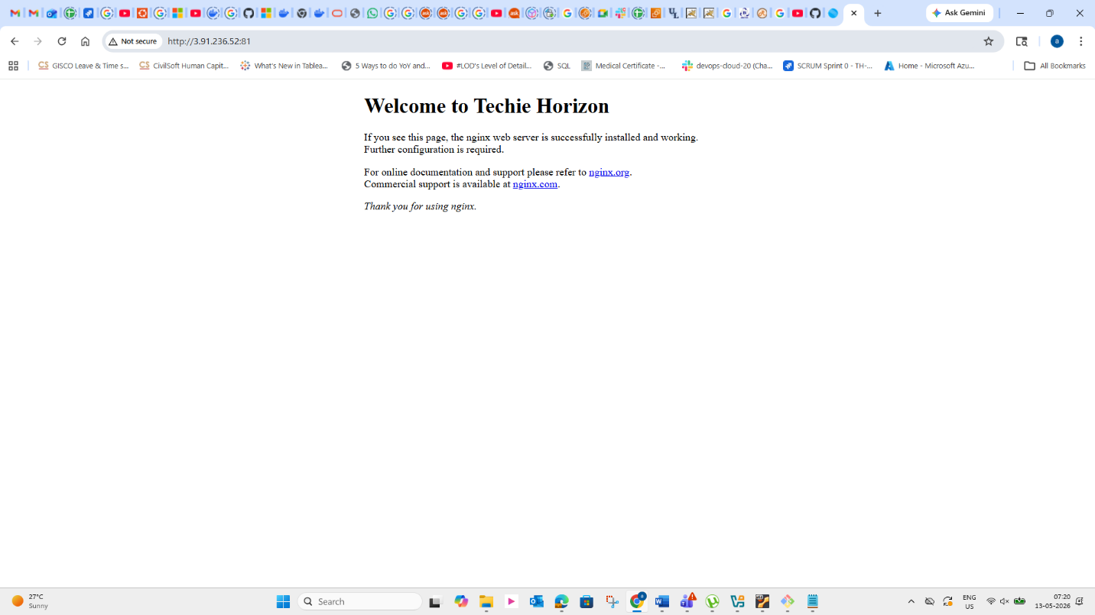

3. Install Apache and run Apache on port number 82
4. Deploy a sample index.html file on Apache
- Command : ssh -i linux_testing.pem ec2-user@3.91.236.52
- Install: yum install httpd
- systemctl start httpd
- systemctl status httpd
- Change the port number from 80 to 81 by editing http.conf
- default configuration location /etc/httpd/conf/httpd.conf
- to change/create a static website by editing in /var/www/html
- default deployment location: /var/www/html
- log file path: /var/log/httpd/access_log
- Deployed a sample file by creating an index.html file

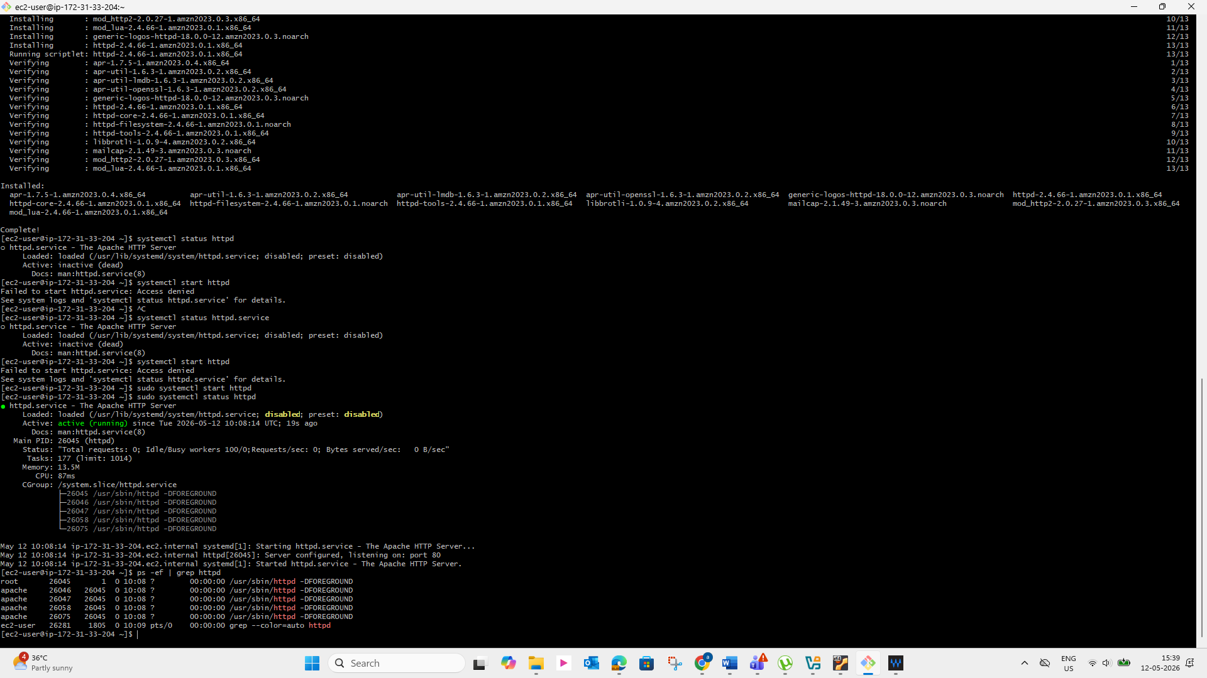
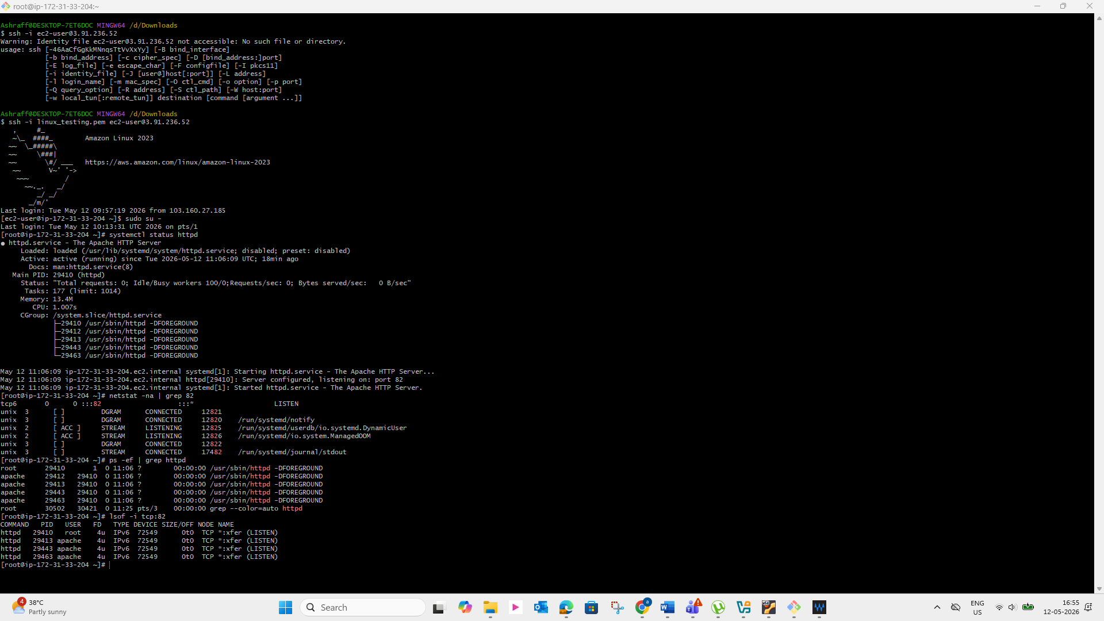
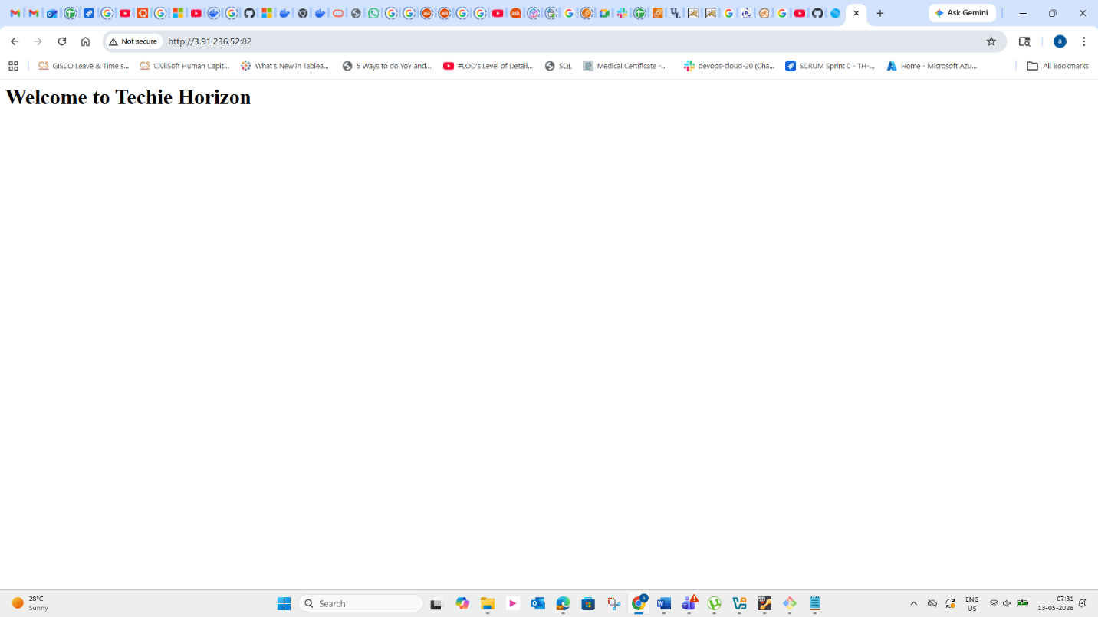

5. Install Apache tomcat on port number 8082
6.Deploy a sample app on webapps

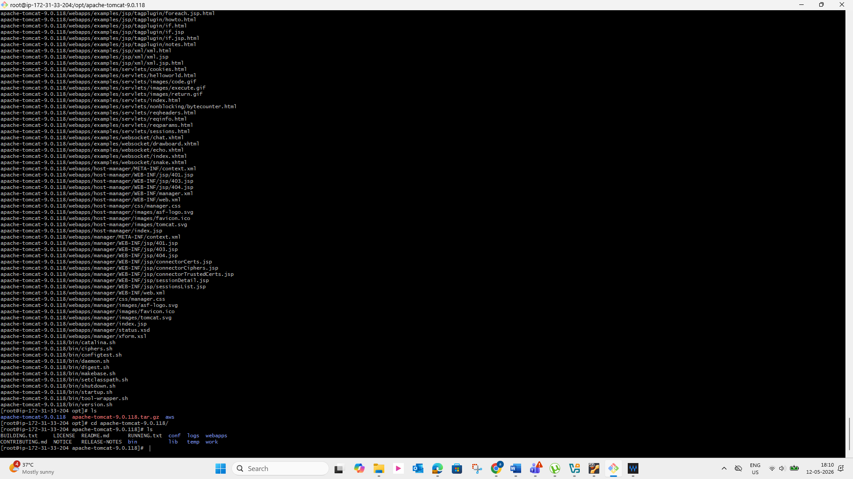
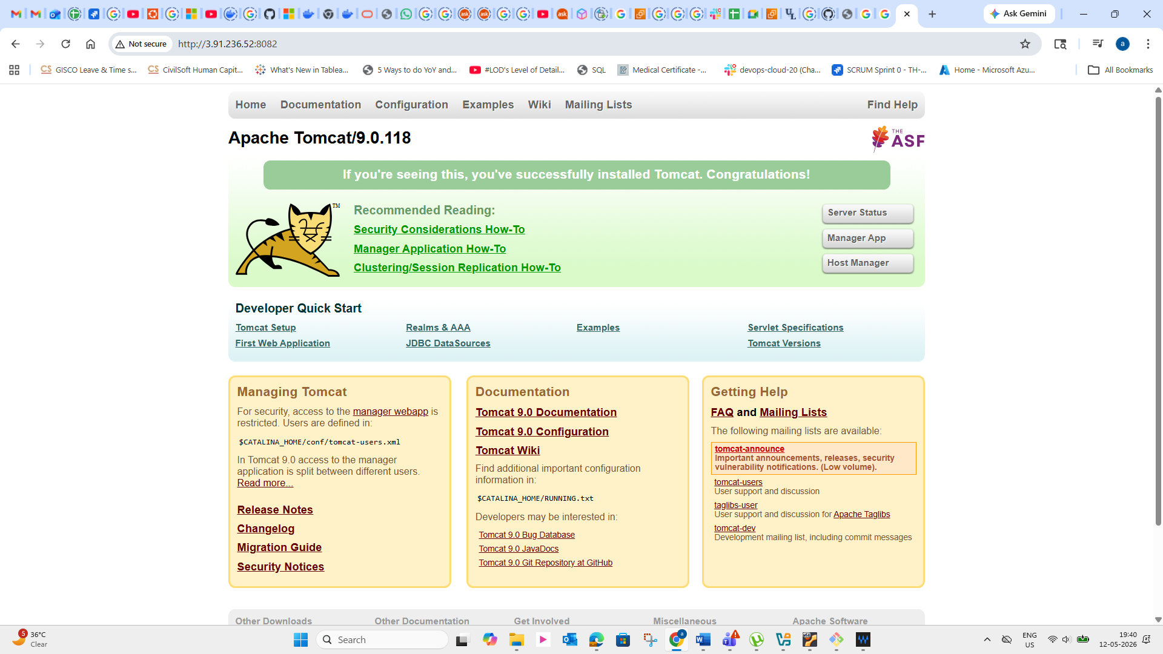

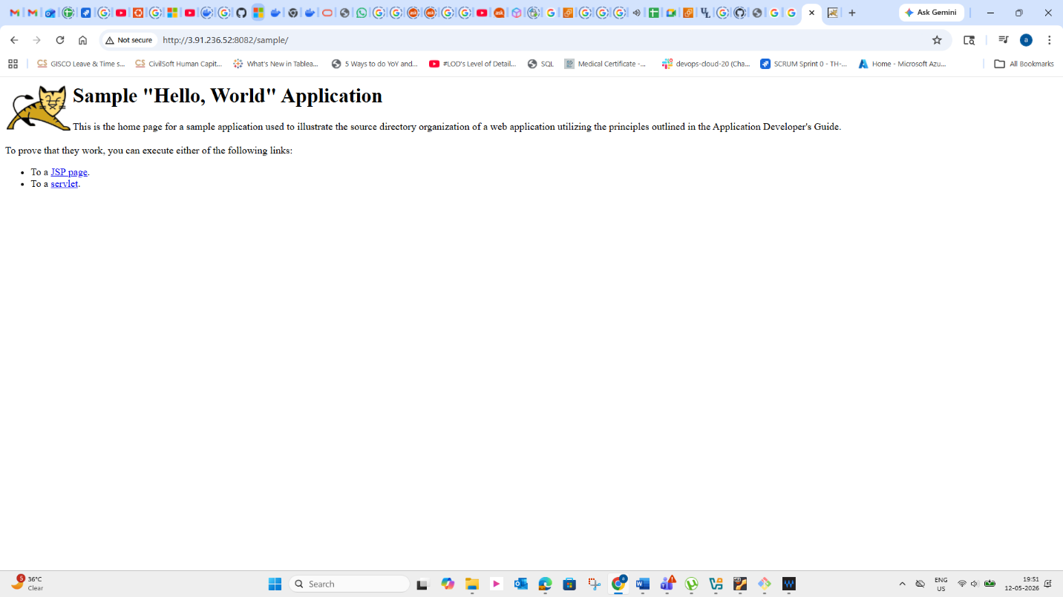

7. Create a tomcat.service file for tomcat.
-Install java-17
-Yum install java-17
-Wget https://dlcdn.apache.org/tomcat/tomcat-9/v9.0.118/bin/apache-
tomcat-9.0.118.tar.gz
- Create tomcat service file
vi /etc/systemd/system/tomcat.service
add settings to the tomcat.service file

[Unit]
Description=Apache Tomcat 9 Web Application Container
After=network.target
[Service]
Type=forking
Environment=CATALINA_HOME=/opt/tomcat
Environment=CATALINA_BASE=/opt/tomcat
Environment=CATALINA_PID=/opt/tomcat/temp/tomcat.pid
Environment=JAVA_HOME=/usr/lib/jvm/java-17-amazon-corretto
Environment='CATALINA_OPTS=-Xms512M -Xmx1024M -server -XX:
+UseParallelGC'
ExecStart=/opt/tomcat/bin/startup.sh
ExecStop=/opt/tomcat/bin/shutdown.sh
User=tomcat
Group=tomcat
UMask=0007
RestartSec=10
Restart=always
[Install]
WantedBy=multi-user.target
-systemctl daemon-reload
-systemctl enable tomcat
-systemctl start tomcat
-systemctl status tomcat

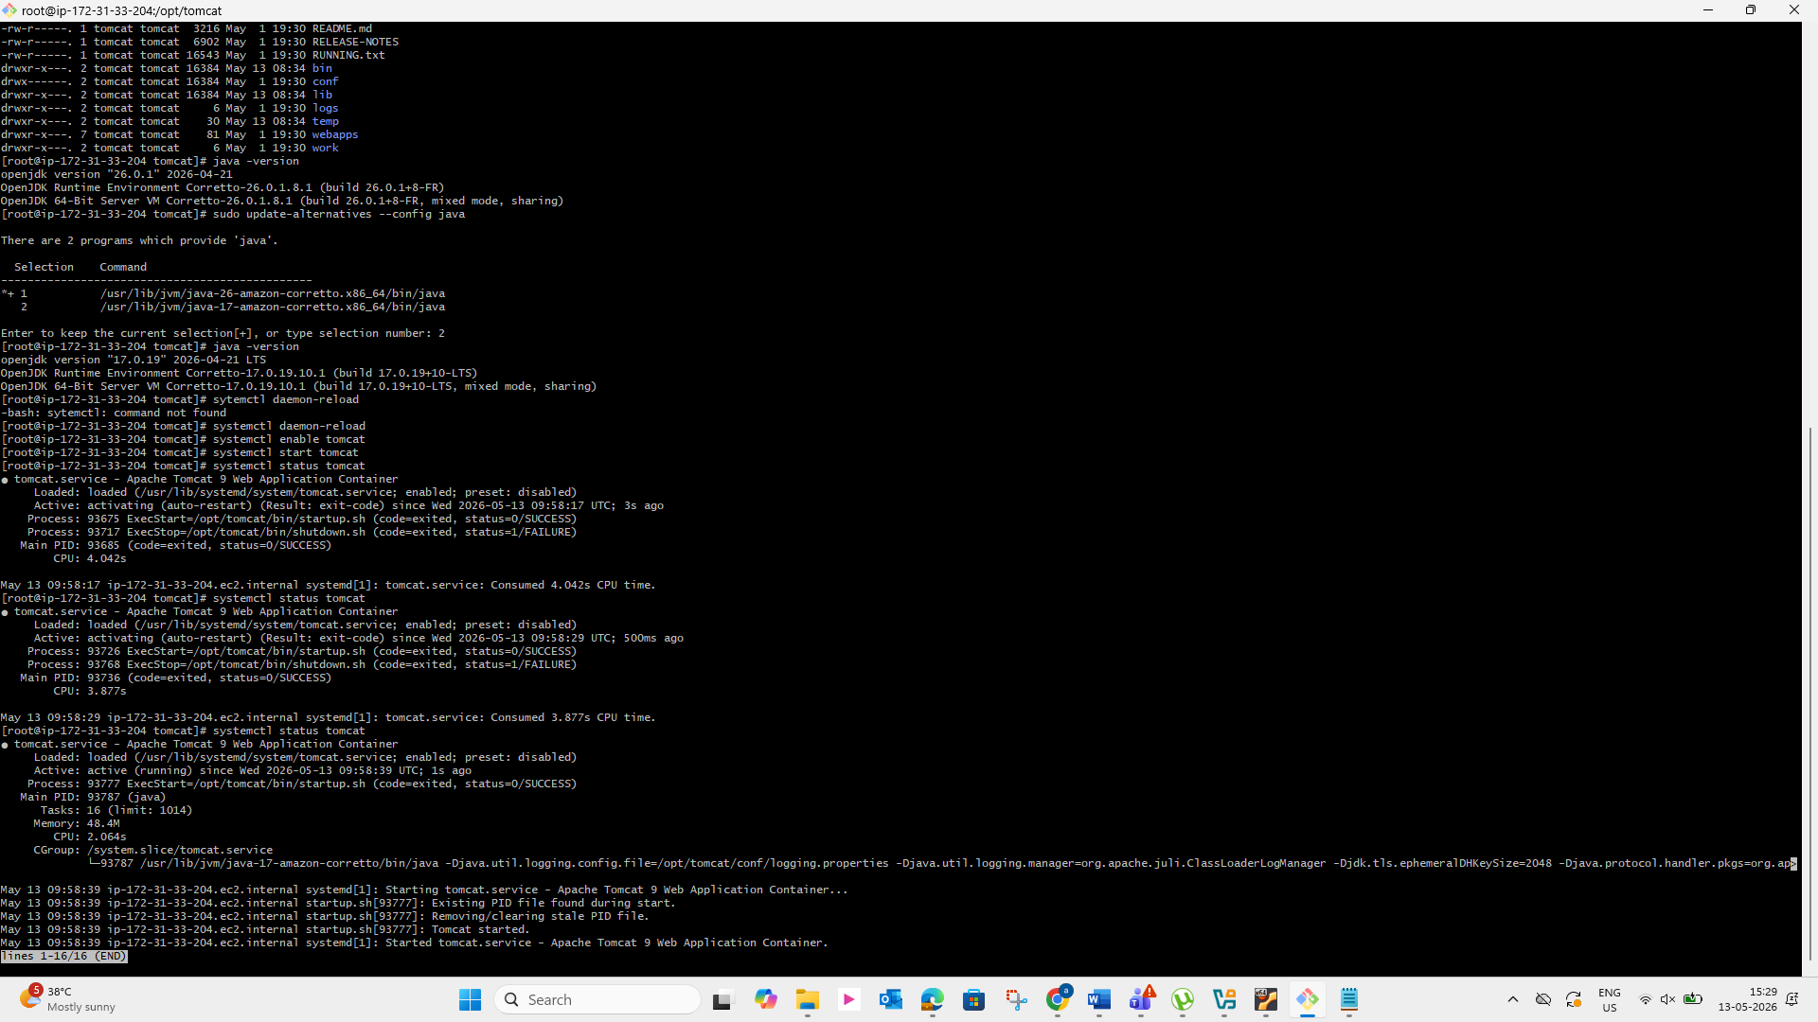

8. Configure HA Proxy server
First Create 3 instances in AWS
Run command to Access the Server-1
ssh -i your-key.pem ec2-user@Pubipaddress of Server-1 instance
sudo -i
yum update -y
Yum install httpd -y
Vi /etc/hosts
Add HA-Proxy-Server Pubic IP Address
Run below command on Server-1
ping load_balancer -c 4
systemctl start httpd
systemctl status httpd
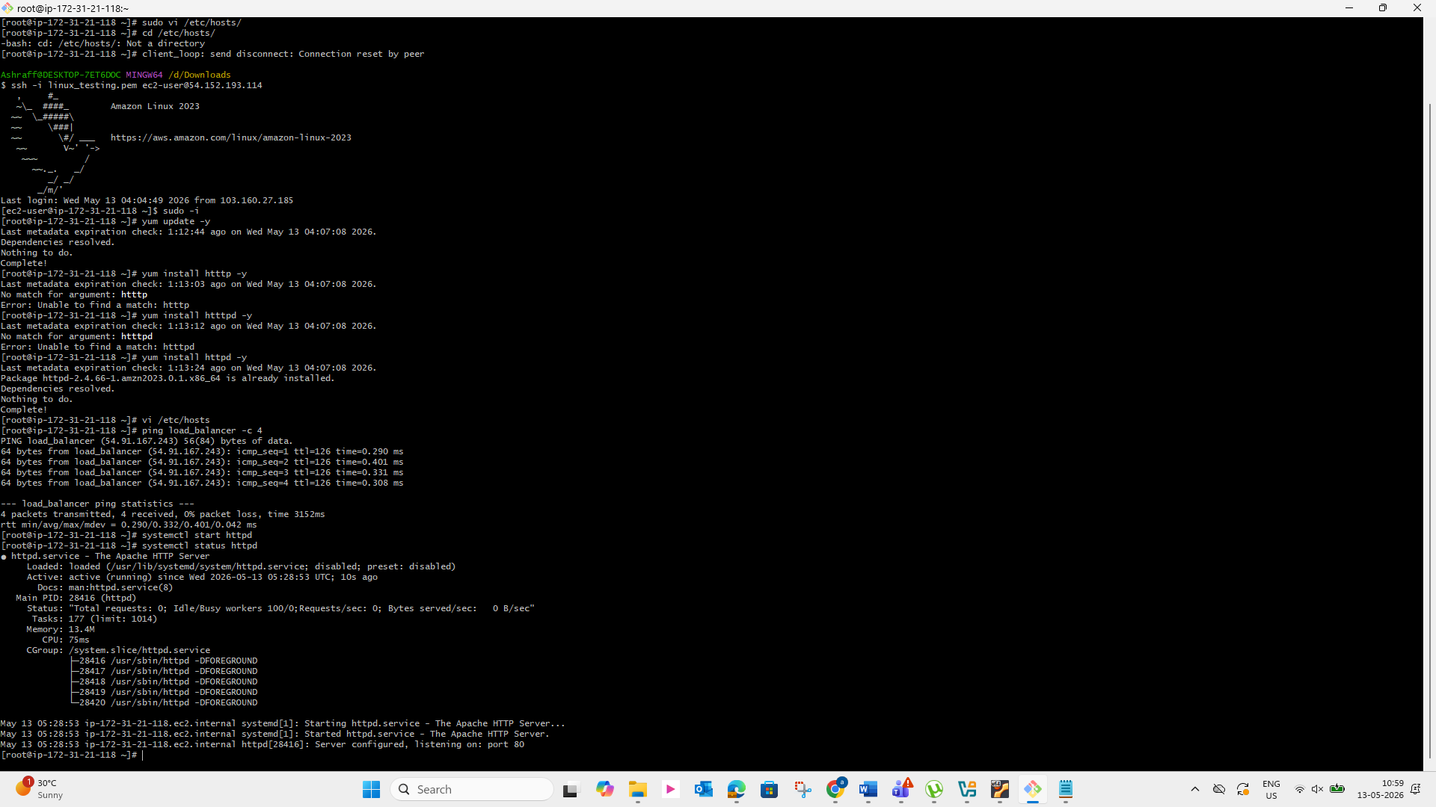
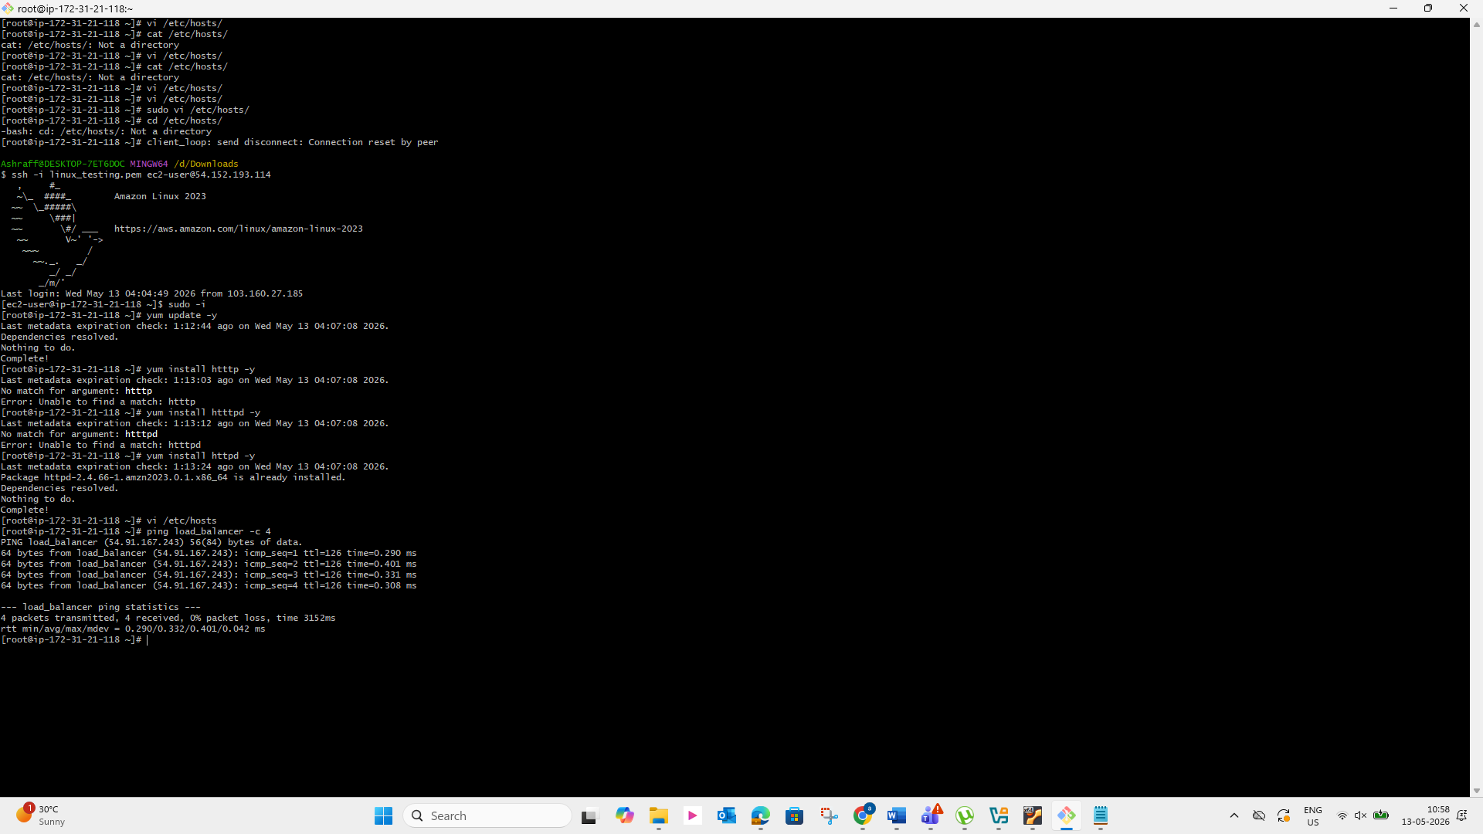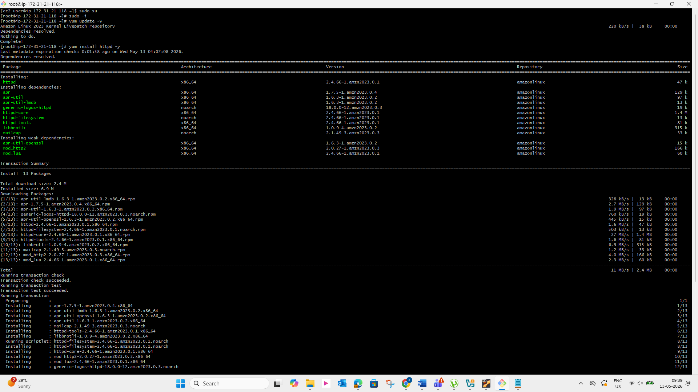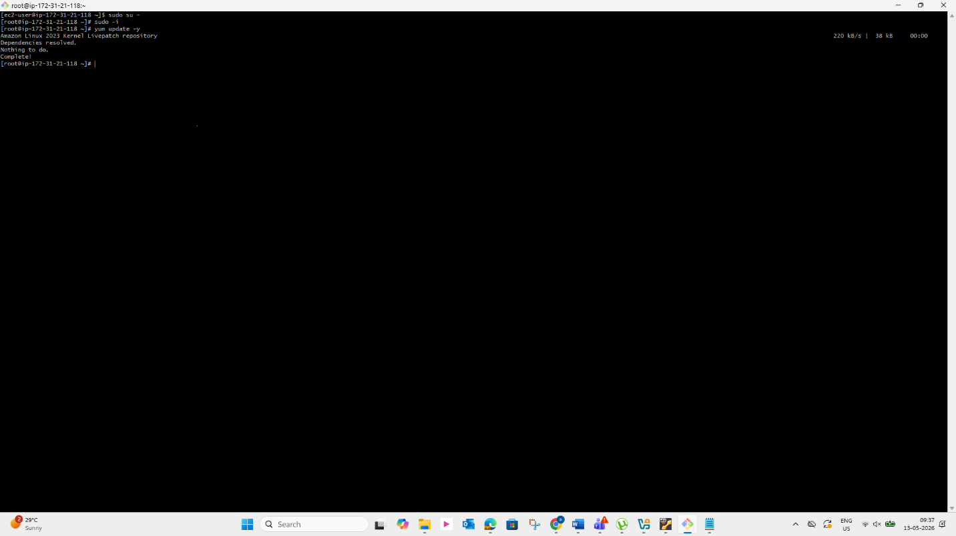

Browse with Server-1 Public IP address:80 it will work
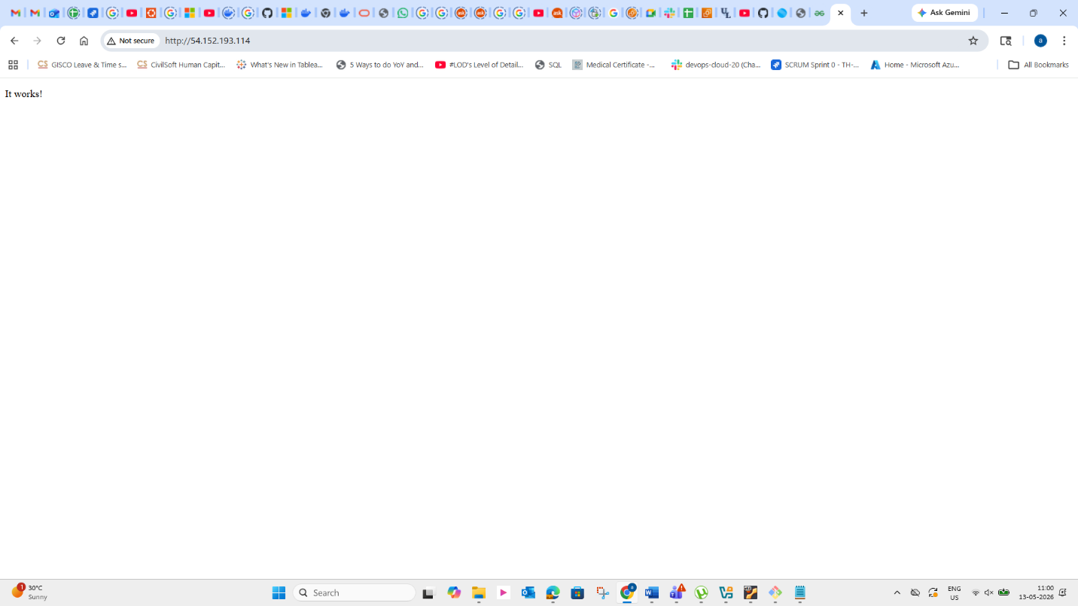

Run following command to Access the Server-2

ssh -i your-key.pem ec2-user@Pubipaddress of Server-2 instance
sudo -i
yum update -y
Yum install nginx -y
Vi /etc/hosts
Add HA-Proxy-Server Pubic IP Address
Run below command on Server-2
ping load_balancer -c 4
systemctl start nginx
systemctl status nginx
Browse with Server-2 Public IP address:80 it will work
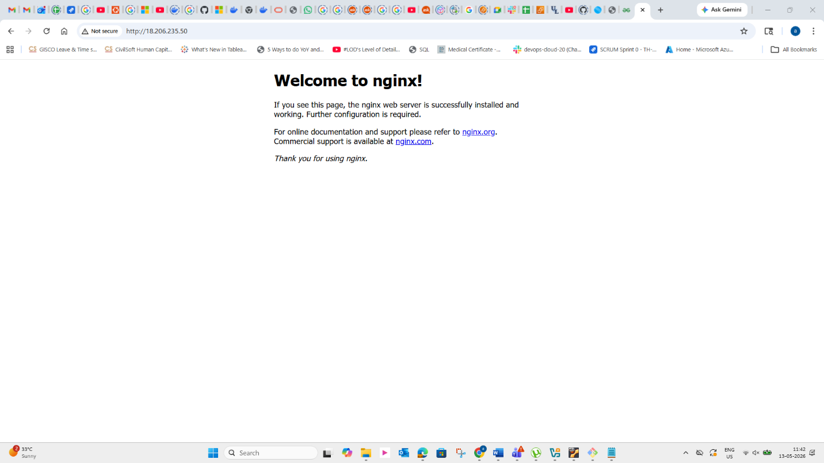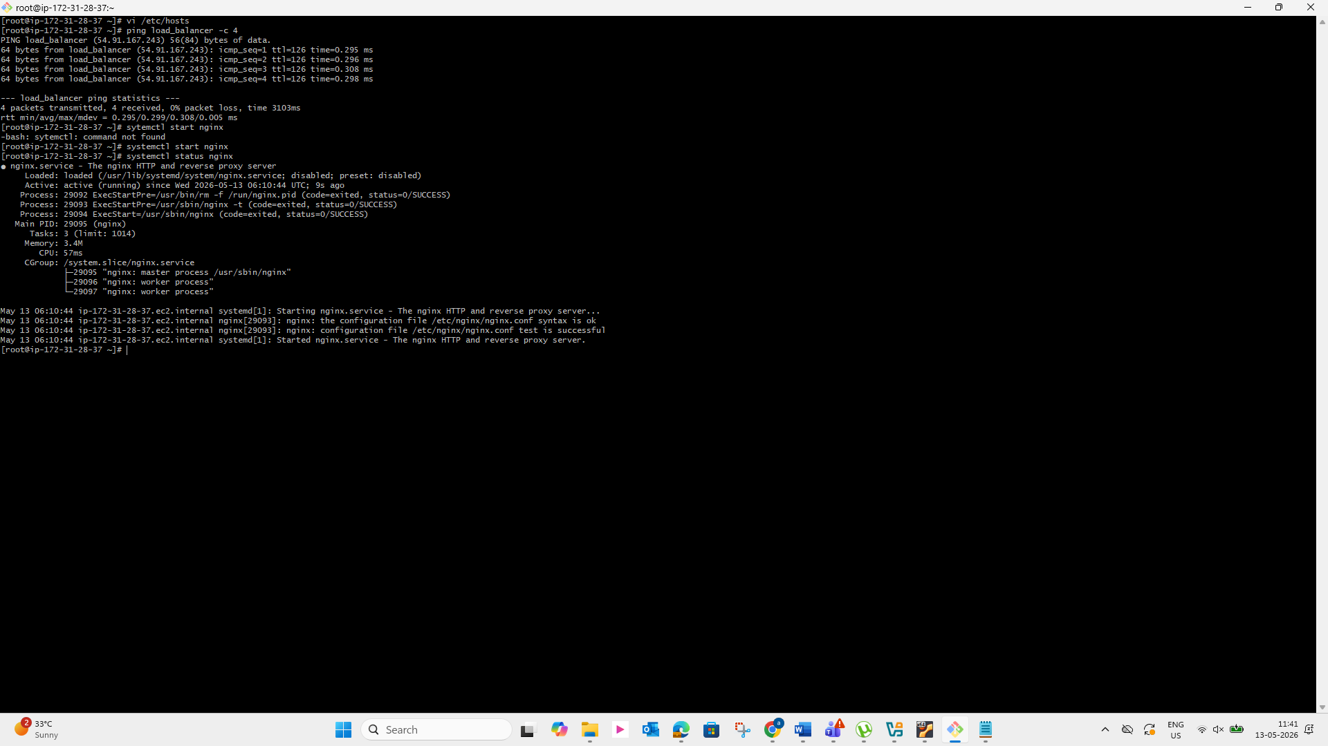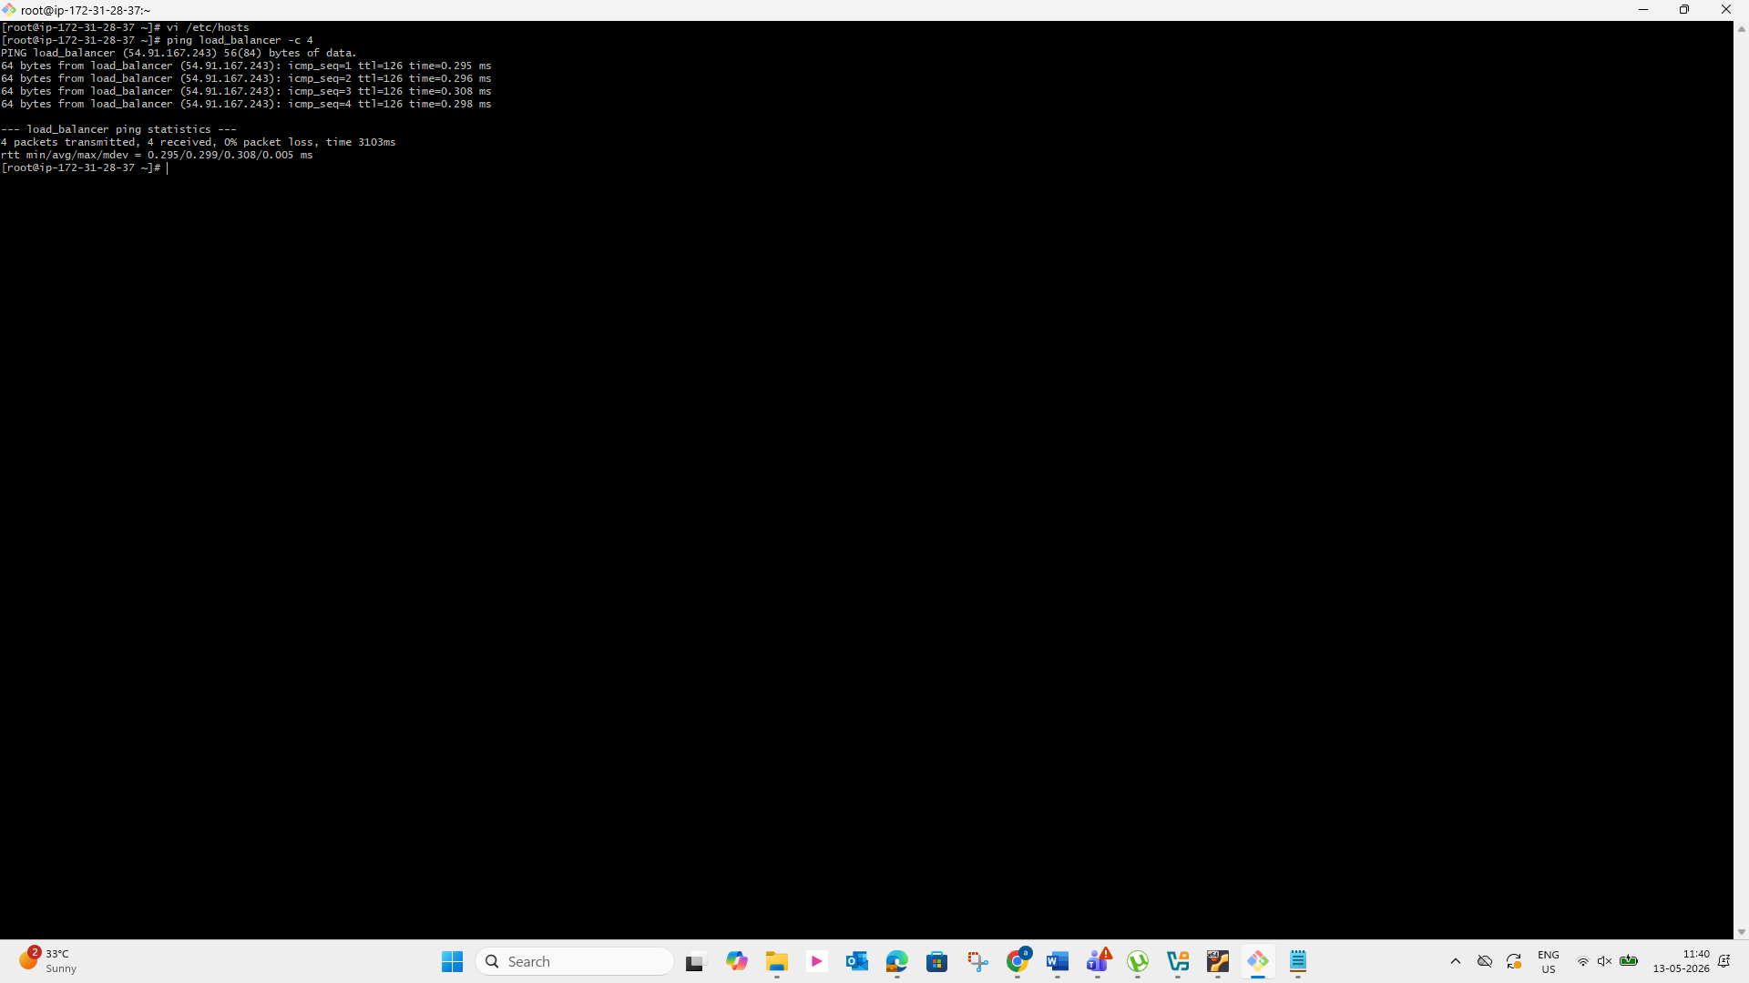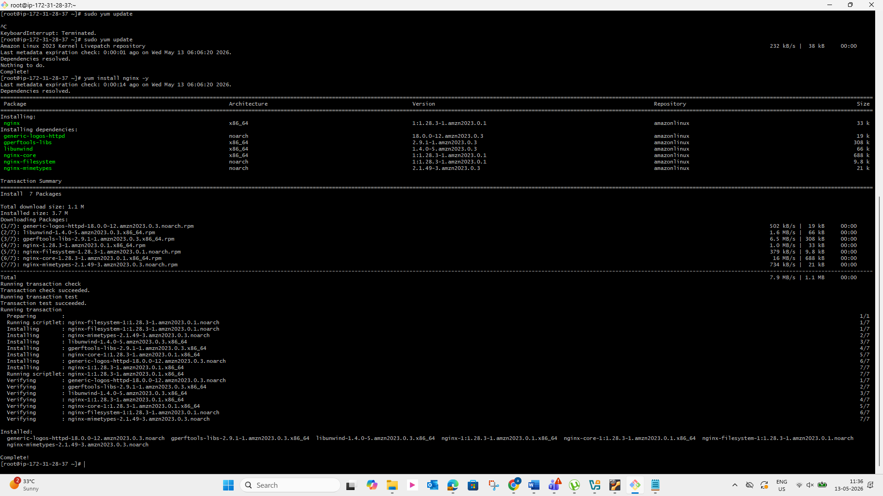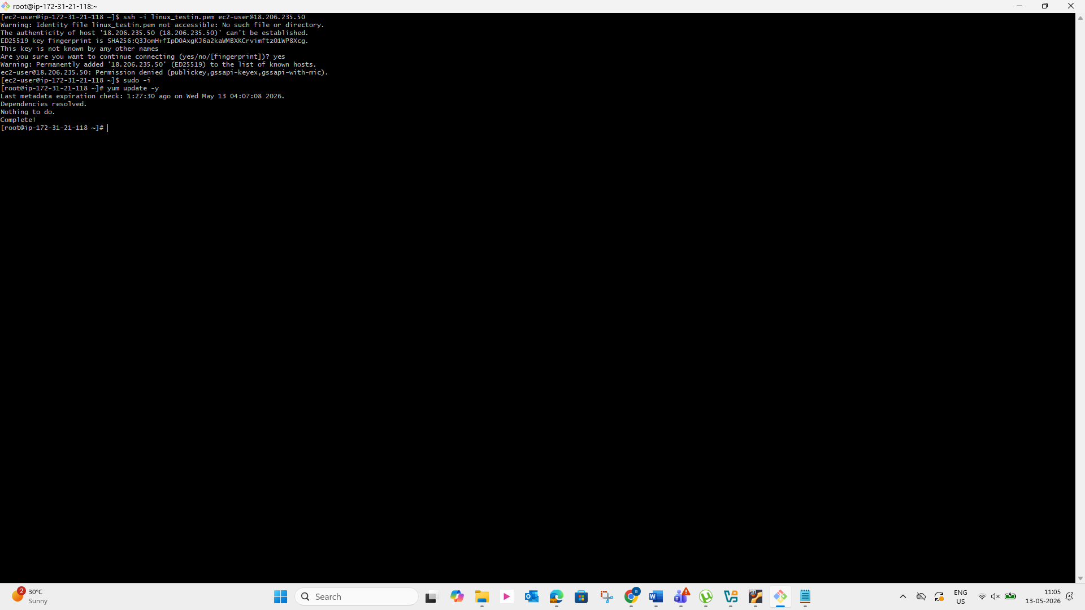
Run following command to Access HA-Proy-Server
ssh -i key-pair.pem ec2-user@Pubipaddress of HA-Proxy-Server instance
sudo -i
yum update -y
Yum install haproxy -y
Vi /etc/hosts
Add Server-1, Server-2 Public IP’s
vi /etc/haproxy/haproxy.cfg
Add Server-1, Server-2 public IP’s
systemctl enable haproxy
systemctl start haproxy
systemctl status haproxy
now browse with HA-Proxy-Server PublicIP:80 it will distribute load to
Server-1, Server-2